# C:\Users\admin\Documents\ayshesh.jpg

DEBRE MARKOS UNIVERSITY BURIE CAMPUS

COLLEGE OF TECHNOLOGY

DEPARTEMENT OF COMPUTER SCIENCE

PROJECT TITELE: WEB BASED PHARMACY MANAGEMENT SYSTEM

PREPAIRD BY:

NAME ID NO

1. AYISHESHIM BIRIHANIE TER/041/08
2. MELESE EBABU TER/060/08
3. GEBRYE DESSIE TER/049/08
4. YISHAMU GETENET TER/033/07

ADVISOR: Andargie M

November/2011 E.C

Burie, Ethiopia

Table of Contents

List of figures ii

List of Acronyms iii

CHAPTER ONE 1

1.1. Introduction 1

1.2. Background of the project 2

1.3. Statement of the problem 2

1.4. Objectives 2

1.4.1. General Objective 2

1.4.2. Specific Objectives 2

1.5. Scope of the project 3

1.6. Significance of the project 3

1.7. Methodology 3

1.7.1 System Requirements 3

1.7.2. Hardware Requirements 3

1.7.3. Software Requirements 4

1.7.4. Software process 4

1.7.4. Programming Language 5

1.7.5. Data collection Methodology 5

CHAPTER TWO 6

2. System Analysis 6

2.1. Overview of the existing system 6

2.1.1. User of the existing system 7

2.1.2 The Proposed System 7

2.2. System Requirement Specification 7

2.2.1. Functional Requirements 7

2.2.2. Nonfunctional requirement 9

2.2.3. Business Rules 9

2.2.4 Change cases 10

2.3. System Requirement Analysis 10

2.3.1 Actor and Use Case Identification 10

2.3.2. Actor identification 10

2.3.3 Use case identification 11

2.3.4 Use Case Diagram 14

2.3.5. Use case description 16

2.3.6. Sequence Diagram 24

2.3.7 Activity Diagram 29

2.3.8. Analysis Class diagram 36

Chapter Three 37

3. System Design 37

3.1 Design Class Diagram 37

3.1.2. Design Class Diagram Description 39

3.2 User Interface Design 43

3.3. Deployment Diagram 47

**List of tables**

Table 1use case description for login 17

Table 2 use case description for create user account 18

Table 3use case description for register new drugs information 19

Table 4 use case description for prepare bill 20

Table 5 use case description for update drugs information 21

Table 6 use case description for view available drugs in the store 22

Table 7 use case description for delete expired drugs information 23

Table 8Class Description of Admin 39

Table 9 Class description of manager 39

Table 10 Class Description of Cashier 40

Table 11 Class Description of Pharmacist 40

Table 12Class Description of Store Coordinator 41

Table 13 Class Description of Request Order 42

Table 14 Class Description of Bill Preparation 42

Table 15 Class Description of Sold drugs 42

# List of figures

Figure1. 1 software development life cycle 4

Figure1. 2 use case diagram 15

Figure1. 3 sequence diagram for login 24

Figure1. 4 sequence for create account 25

Figure1. 5 sequence diagram for register drugs 26

Figure1. 6 sequence diagram for view available drugs 26

Figure1. 7 sequence diagram for prepare bill 26

Figure1. 8 sequence diagram for delete expired drugs 27

Figure1. 9 sequence diagram for update drugs information 28

Figure1. 10 activity diagrams for login 29

Figure1. 11 Activity diagram for create account 30

Figure1. 12 Activity diagram for register new drags information 31

Figure1. 13 Activity diagram for update drugs information 32

Figure1. 14 Activity Diagram for prepare bill 33

Figure1. 15 Activity Diagram for view available drugs in the store 34

Figure1. 16 Activity diagrams for delete expired drugs 35

Figure1. 17 Analysis class diagram 36

Figure1. 18 User Interface Design for Login 43

Figure1. 19 User Interface Design for Create New User Account 44

Figure1. 20 User Interface Design for Drug Registration Form 45

Figure1. 21 User Interface Design for Check Expired Drugs 46

Figure1. 22 Deployment Diagram 47

# 

# List of Acronyms

* Admin-Administrator
* CD_ compact Disk
* CSS-Cascaded Style Sheet
* BR-Business Rule
* HTTP_ Hyper Text Transfer Protocol
* ID No– Identification number
* MySQL – My Structured Query Language
* PHP-Hypertext Preprocessor
* SQL_ Structural Query Language
* UC – Use Case
* UI-User Interface
* UML – Unified modeling language

# CHAPTER ONE

# 1.1. Introduction

Technology is spreading its wing in almost every walks of human life activities. Now a day it is better if every activity is done using new technology in order to fulfil the need of human being, Organization and Enterprise. As today’s world there are all organizations needs to be preferable, computable and work on fastest way in order to satisfy user’s interest i.e. they should have facilitate their activities in computerized way. Hence Pharmacy management system is a system that is designed to improve accuracy and to enhance the performance of the task in the pharmacy like, registration of drugs, searching drugs information, checking expired date of drugs, report and other tasks. It is a computer and web based system which helps employee’s to facilitate the activity of the pharmacy in appropriate manner. The pharmacy has two places which the drugs are available. These are stock and store. The stock is the place in which the drug that needs to be sold is stored. And the store is the place in which the new bought drug is stored. Currently all activities in the pharmacy performed manually. It requires the pharmacist monitor manually each drug that is available in the pharmacy or not. This usually leads to mistakes as the workload of the pharmacist increases.

## 1.2. Background of the project

Today with the growth of population number, our world is facing serious problems. Many organizations are in trouble to accommodate these large numbers of people according to their needs. Many problems in the organizations are associated with the increasing number of customers and way of helping them. Currently, all activities of pharmacy system are going on manually, which lead to wastage of time, labor, accuracy, and speed. Pharmacy System is the backbone of the medical health sector. Currently it uses manual system in order to manage the overall activity of the pharmacy, which leads to wastage of time, labour and material. So it should be advanced and computerized to provide fast services for the community and also for other users of the system like manager, pharmacist, store coordinator and cashier.

## 1.3. Statement of the problem

* Managing a very large pharmacy with records on papers will be tedious and difficult to keep track of inventory with regards to the drugs in the stock inside the pharmacy.
* Since it is manual system quantity of drugs available based on the categories and their functions can’t be easily known. Due to this the patient can’t get the drug they want.
* Difficulty of getting full information about drugs when needed immediately.
* Preparing report for each drug takes long time.
* It is difficult to identify which drugs are out dated or expired.
* The most sensitive data is lost because of they are paper based.
* Most of the time redundant data occur.

## 1.4. Objectives

### 1.4.1. General Objective

The main objective of this project is to develop a web based pharmacy management system.

### 1.4.2. Specific Objectives

The specific objectives of the project are:-

* Existing System analysis.
* Gather requirements for the system
* Identify functional and nonfunctional requirements for the new system
* Develop the system documentation with detailed UML specifications
* Design and develop a new system that can overcome the problem of the current system
* Test and Implement the proposed system
* Current System design.
* To create fast and reliable system.
* To design a user friendly interactive system.
* Automating drug selling

## 

## 1.5. Scope of the project

Due to shortest time and system complexity, our web based pharmacy management system is performed the following services.

* Provide some basic information about drugs.
* Admin can create, update and deactivate user account
* The store coordinator register drugs information, check expired date, delete expired drugs, and generate report
* The Pharmacist check expired date and register soled drugs information
* The cashier prepare bill and print receipt and generate report
* Customer can search drug information and provide comment online
* The manager, cashier and pharmacist can generate report
* Manager can sent order to the supplier
* The supplier can view, accept and reject order and, add comment
* All users can search drug information

## 

## 1.6. Significance of the project

After this project is accomplished and properly used it provides great benefits to the manager, pharmacist, cashier, customer and supplier. Some of the significant that the team has identified are listed out as follows:

* Reduce manual process and administrative cost to maintain existing system.
* Reduce time, cost and redundancy of information or data.
* Improving efficiency, control and security of existing system.
* Facilitate the strategy of processing of pharmacy management system.
* Improve employee moral by eliminating burdensome and boring job tasks.

## 1.7. Methodology

### 1.7.1 System Requirements

### 1.7.2. Hardware Requirements

* Laptop and desktop computer to accomplish all activity of the project.
* Flash disk and CD for backup data
* Printer**:** For printing the documentation.
* Paper : To store the documents in the form of hardcopy

### 

### 1.7.3. Software Requirements

* Microsoft word 2010: it is software that we use to write our system documentation.
* Microsoft PowerPoint 2010: is software that we use for presentation.
* E draw Max is software which we used to draw unified modeling diagram Such as sequence diagram, activity diagram etc.
* Web browsers like Mozilla Firefox to display our project.
* Operating System: - Windows 7.
* Notepad++ Editor: used to edit implementation code of the project.
* WAMP: to test each program.

### 1.7.4. Software process

* Software process is a set work phases that are applied to design and build a software product. Software process is also known as software development life cycle.
* There are many software process models. Among those models we choice iterative software process models.

**Iterative software process:** the basic idea behind this model is to develop a system through repeated cycles.

* The iteration involves the redesign and implementation of iteration is to be simple, straightforward, and modular, supporting redesign at that stage.

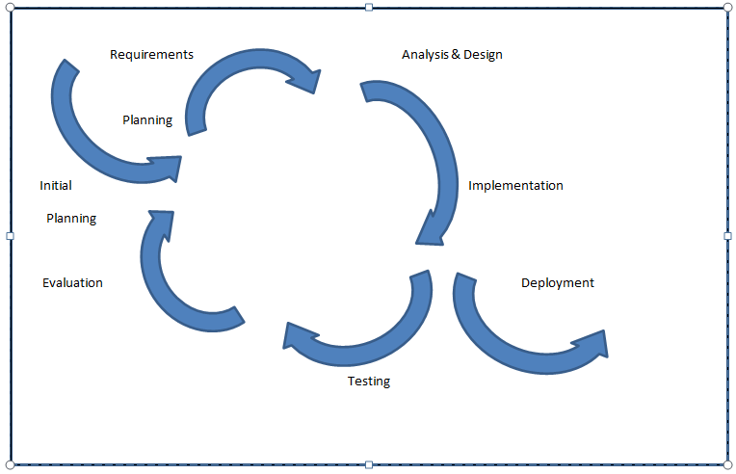

Figure1. 1 software development life cycle

### 

### 1.7.4. Programming Language

The implementation of the system can be user friendly and develop by using the following tools.

**FRONT END:**

* HTML: to define the content of web pages
* CSS: to specify the layout of web pages/formatting.
* JAVASCRIPT: program the behavior of web pages
* PHP- is a server scripting language

**BACK END:**

* Database: MYSQL

### 

### 1.7.5. Data collection Methodology

* Questionnaires: we gather the information by spreading questioner to the pharmacy worker and analyses their feedback.
* Interview: we gather the information by interviewing the workers
* Observation: we gather information by observing how they worked
* Reading, softcopy ,online books and searching internet for literature review
* We use brainstorming to share information between group members.

# 

# CHAPTER TWO

# 2. System Analysis

## 2.1. Overview of the existing system

The current system of pharmacy information management is manual system. That means checking expired date and availability of drugs is done by checking every drug inside the pharmacy. This leads loosing time and resource of the organization. An existing system compromises different players or users to carry out its job. The current pharmacy management system is time taking, unqualified, costly and not satisfactory. Pharmacist spend much time to search drugs location on the shelf and check expired date of drugs in the store, remembering the selling price of the drugs is very difficult for cashiers because of the selling price of drugs is prepared manually by paper-based method, and the manager face difficulties to know the amount of soled drugs and available drugs. The major functionalities and the scope of the existing system are listed below.

* Purchasing drugs from the supplier and Selling for customers manually
* Register drugs information by using paper
* The pharmacist check expired date of drugs manually
* The cashier prepare receipt for customers by paper
* Cashiers and pharmacists prepare report and submit to the manager by using hard copy
* Manager request purchase by using telephone or paper based method

**Work in the Pharmacy will be done in the following way:**

1. The Drugs will come in the store.

2. Store coordinator will record the information of the drugs on paper

3. Some drugs move from store to stock and place on the shelf

4. The customer will come and provide written prescription for the pharmacist

5. The pharmacist view prescription and takes drugs from the shelf and sell for customer

6. The cashier prepare bill

7. Customer will pay money to cashier.

8. The cashier Print receipt for customer

9. All the drugs will be packed and delivered to the customer.

### 2.1.1. User of the existing system

The existing system compromises different players to carry out its job. Among those different actors (players), the most common are:

* **Pharmacist:** The customer comes with the ordered prescription then the pharmacist looks that order of drug and gives the drug accordingly. The customer gets his/her requested service from the pharmacist*.*
* **Pharmacy manager****:** The manager gets reports from the pharmacist, store coordinator, and cashier. The reports help the manager to see how services are given to the client.
* **Store coordinator**: Store coordinator is responsible to register the drugs that buy from the private sectors or from the governmental association, and also control the drug that are goes out to the stock.
* **Cashier:** The cashier receives the cost of the drug from the customer ordered by the pharmacist and prepare bill.
* **Supplier:** the supplier is responsible to supply drugs to the pharmacy.
* **Customer:** the customers get information from the pharmacist orally, how they use drugs properly.

### 2.1.2 The Proposed System

The system proposed to apply on pharmacy management is the automated and web based management system. The main objective of this system is to manage and control activities such as searching drugs information, prepare bill, registration of drugs information, checking expired date, delete expired drugs, order drugs and supplementary material along with to facilitate an efficient communication between the many participants in the pharmacy including: manager, pharmacist, cashier, store coordinator, supplier and customer. The proposed system concerns the requirements of the customer and the employees. It has the following qualities including the qualities of the existing system

* Reduction in processing cost
* Error reduction
* Improve reporting
* Ability to meet user requirements
* Improves resource uses
* Reduction in use of the paper
* Every work process activity is done by computer means no need of hardcopy

## 2.2. System Requirement Specification

### 2.2.1. Functional Requirements

## The functional requirement is the services that are provided by the system. It also describes the interactions between the system and the user.

## The new system is expected to provide the following functionalities.

**Pharmacy manager:**

* View available drugs in the store
* View soled drugs information
* View available drugs in the stoke
* Send order for suppliers
* Generate report
* View comment
* Process payment

**Pharmacist:**

* Search drugs information
* Check Expired date
* Register sold drugs information
* View Available drugs found in the stock
* Generate report

**Cashier:**

* prepare bill for the customer
* Generate report
* Print receipt

**Store coordinator:**

* Register new drugs information
* View available drugs in the store
* Update drugs information
* View available drugs in the stoke
* Generate report
* Check expired date of drugs

**Supplier:**

* View Order
* Accept Order
* Reject Order
* Add comment about the pharmacy

**Customer:**

* Search drugs information online
* Add comment about the pharmacy

**Admin:**

* Create, update and deactivate users account

### 2.2.2. Nonfunctional requirement

#### Nonfunctional requirement describes user visible aspects of the system that are not designed to the functional behavior of the system. Some of the nonfunctional requirements are:

#### Performance

#### The system will function fast.

* Very short response time.
* The system must be operationally all over the year.
* The system must adaptable for different operating system since we use PHP , HTML , CSS, JAVASCRIPT language which is easy to understand and simple to develop the system.
* **User interface**
* The system should be user-friendly interactive.
* The pharmacist can easily retrieve information in the stock.
* The skilled person interacts with the system properly.
* The system should more interactive, since we use interactive and easy understandable languages like HTML, CSS, PHP to develop our system.

* **Security and access permission**
* We make the system more secured by using strong password
* The system use user’s name and password to authenticate authorized user.
* The system should allow login to only authorized users.
* **Storage requirement**

The system store all the data related with all the tasks performed into the database

### 2.2.3. Business Rules

**BR1:** The manager should send order to the supplier

**BR2**: The supplier should view, accept, reject order add comment

**BR3:** Manager should View comment, process payments, check expired date, view available drugs in the store, generate report, view available drug in the stock.

**BR4:** Store coordinator should register drugs information that comes from supplier.

**BR5:** Drugs should order in their identifiable type to facilitate searching requested drug.

**BR6**: The pharmacist and store coordinator check expired date of drugs receipt for customer

**BR7:** Expired drugs must be removed from the pharmacy.

**BR8:** The cashier must prepare receipt

### 2.2.4 Change cases

* The system will computable with new developed operating systems like window, Linux, mac, android etc. since those PHP, HTML, CSS languages are computable with those operating systems and we develop the system using those languages.
* Likely future changes (update) to either the system, in terms of its capabilities and properties are computable with the new version.
* The system will promote related international rules and regulations.

## 2.3. System Requirement Analysis

### 2.3.1 Actor and Use Case Identification

System use case refers sequential activities that to be done by system for each system features. It is the structural representation of textual user requirements stated into diagrammatic and more understandable format. This shows that how the system performs these user requirements.

### 2.3.2. Actor identification

In the use cases an actor interact with the system to perform a piece of meaningful work that helps them to achieve a goal and has access to define their overall role in the system and the scope of their action. Depending on the above explanation actors in this system are the following:

* **Manager:** Controls the overall activity in the pharmacy.
* **Pharmacist:** Manages the drug information in the stock.
* **Store coordinator:** Manages the outgoing and incoming drug from the store.
* **Cashier:** Collect the price of the sold items and generate report to the manager.
* **Supplier:** the supplier is responsible to supply drugs to the pharmacy.

### 

### 2.3.3 Use case identification

Each Use Case describes the functionality to be built in the proposed system, which can include another Use Case's functionality or extend another Use Case with its own behavior. The most important and basic use cases of this system are the following:-

* Login
* Create account
* Update account
* Deactivate account
* Register new drugs info
* View drug
* Delete expire drugs
* Check expire date
* Process payment
* Search drugs
* Send order
* Add comment
* View comment
* View order
* View available drug in the stock
* Register sold drugs
* Accept order
* Reject order
* Log out
* Generate report
* Prepare bill
* Print receipt
* View available drug in the store
* Update drugs

### 2.3.4 Use Case Diagram

A use case diagram is a representation of a user's interaction with the system that shows the relationship between users and the different use cases in the system.

* **Use Case:** A use case describes a sequence of actions that provide a measurable value to an actor
* **Actor:** An actor represents a person, organization or any external system that interacts with the system



Figure1. 2 use case diagram

### 2.3.5. Use case description

The following consecutive tables show the use case description for each of the use cases that has identified in the above use case diagram. Each table contains the use case name, short description, pre-condition, post condition, Basic subjects of action and alternative subject of action the actor initiates and interacts with the use case, description of the use case and typical subject of events that show the interaction between the actor and the use case which enable the team to easily depict the functions of the proposed system.

|  |  |  |
| --- | --- | --- |
| **Use case number** | **UC 01** | |
| **Use case name** | Login | |
| **Priority** | High | |
| **Actor** | Manager, Cashier, Pharmacist, supplier, Store coordinator ,customer and admin | |
| **Description:** | The user enters authorized username and password in order to access the system. | |
| **Precondition** | The user should create account and have user name and password. | |
| **Post condition** | The users successfully pass the login page and perform their task on the system. | |
| **Basic course of action** | **User action** | **System response** |
| 1. Open home page.  2. click the Login link  4. Enter the authorized username and password in the login form.  5. Click on **LOGIN** button  8. End use case. | 3. Display the login page with login form.  6. Check the authorized username and password.  7. If the username and password is correct users can access the system based on their privilege. |
| **Alternative course of action** | 9. If the username and password is incorrect | The system displays” please enter correct username and password t” message. and returns to basic course of action 3 |

Table 1 use case description for login

|  |  |  |
| --- | --- | --- |
| **Use case number** | UC 02 | |
| **Use case name** | Create user account | |
| **Actor** | Admin | |
| **Description** | The admin creates account for user in order to control activities on system. | |
| **Pre-condition** | The admin must login to the system by using his/her username and password, and fill users information | |
| **Post-condition** | The user can get username and password to access the system. | |
| **Basic course of action** | **User action** | **System response** |
| 1. The admin select create account link.  3. The administrator fills the required information and click on **submit** button.  7. Use case end. | 2.The system display create account page with form  4. The system validates user inputs.  5.The system registers the users into the database  6. Display user account successfully created. |
| **Alternative course of action** | If the information is invalid, The system display error message and go to step 2 | |

Table 2 use case description for create user account

|  |  |  |
| --- | --- | --- |
| **Use case number** | UC 03 | |
| **Use case Name** | Register new drugs information | |
| **Priority** | High | |
| **Actor** | Store coordinator | |
| **Description** | The store coordinator register drugs information when new drugs come in to the store | |
| **Precondition** | The store coordinator must login with his/her own username and password. | |
| **Post condition** | The drugs information registered. | |
| **Basic course of action** | User Action | System Response |
| 1. click the **Register new drugs** link  3. Fill the drugs information on the form.  4. Click on **Register** button | 2. The system displays the form.  5. The system verifies validation of inputs.  6. The system displays “registered successfully” message.  7. Use case end. |
| **Alternative Course of action** | If the inputs are invalid | The system displays” please enter correct input” message.  and returns to basic course of action 3 |

Table 3 use case description for register new drugs information

|  |  |  |
| --- | --- | --- |
| **Use case number** | UC 04 | |
| **Use case name** | prepare bill | |
| **Actor** | Cashier | |
| **Description** | The Cashier calculate bill for customer during the customer buy drugs | |
| **Pre-condition** | The Cashier must login to the system by using his/her username and password | |
| **Post-condition** | The Cashier can calculate the bill for the customer | |
| **Basic course of action** | **User action** | **System response** |
| 1.click **prepare bill** link  3. The cashier fills the required information and click on **calculate** button.  5.the cashier generate receipt and click print button | 2.The system display the form  4. The system calculates the bill and display.  6. the system print the receipt  7. Use case end. |

Table 4 use case description for prepare bill

|  |  |  |
| --- | --- | --- |
| **Use case number** | **UC 05** | |
| **Use case name** | Update drugs information | |
| **Priority** | High | |
| **Actor** | Store coordinator | |
| **Description:** | If there is any mistake during registration the store coordinator can update/modify drugs information | |
| **Precondition** | The Store coordinator should create account and have user name and password. | |
| **Post condition** | The drugs information updated successfully. | |
| **Basic course of action** | **User action** | **System response** |
| 1. The Store coordinator click the **Update** link  3.select the drug he/she wants to update and click **update** button  5. The Store coordinator modify the drugs information and click on **save** button | 2. The system displays the combo box.  4. The system display drugs information  6. The system displays “Updated successfully” message.  7. End use case. |
| **Alternative course of action** | 7. If the modified information is invalid | The system displays” please enter correct input” message. and returns to basic course of action 4 |

Table 5 use case description for update drugs information

|  |  |  |
| --- | --- | --- |
| **Use case number** | **UC 06** | |
| **Use case name** | View Available Drugs in the store | |
| **Priority** | High | |
| **Actor** | Store coordinator and Manager | |
| **Description:** | Store coordinator and Manager can view available drugs in the store | |
| **Precondition** | The Store coordinator and manager should create account and have user name and password. | |
| **Post condition** | Store coordinator and Manager view available drugs information. | |
| **Basic course of action** | **User action** | **System response** |
| 2. The users click on View Available drugs link | 1. The system displays list of activities.  3. The system display Available drugs information  4. End use case. |

Table 6 use case description for view available drugs in the store

|  |  |  |
| --- | --- | --- |
| **Use case number** | UC 07 | |
| **Use case name** | Delete Expired drugs information | |
| **Priority** | High | |
| **Actor** | Store coordinator | |
| **Description** | If the drugs are expired, they must be deleted from the system | |
| **Pre-condition** | The Store coordinator must check the expired date of the drugs | |
| **Post-condition** | The Store coordinator can delete drugs information from the system | |
| **Basic course of action** | **User action** | **System response** |
| 1. The Store coordinator check expired date of the drugs  3. click on Delete button | 2.The system display expired drugs information  4.The system delete the drug information from the system and display “deleted successfully” message  5. Use case end. |

Table 7 use case description for delete expired drugs information

### 

### 

### 2.3.6. Sequence Diagram

Sequence diagrams show the interaction between participating objects in a given use case. They are helpful to identify the missing objects that are not identified in the analysis object model. To see the interaction between objects, the following describe the sequence diagram of each identified use cases.



Figure1. 3 sequence diagram for login



Figure1. 4 sequence for create account



Figure1. 5 sequence diagram for register drugs



Figure1. 6 sequence diagram for view available drugs

Figure1. 7 sequence diagram for prepare bill



Figure1. 8sequence diagram for delete expired drugs



Figure1. 9 sequence diagram for update drugs information

## 

### 2.3.7 Activity Diagram

Activity diagrams are used to show how different workflows in the system are constructed, how they start and the possibly many decision paths that can be taken from start to finish. They may also illustrate where parallel processing may occur in the execution of some activities.



Figure1. 10 activity diagrams for login



Figure1. 11 Activity diagram for create account



Figure1. 12 Activity diagram for register new drags information



Figure1. 13 Activity diagram for update drugs information



Figure1. 14 Activity Diagram for prepare bill



Figure1. 15 Activity Diagram for view available drugs in the store



Figure1. 16 Activity diagrams for delete expired drugs

### 2.3.8. Analysis Class diagram

User

userid

firstName

lastName

sex

address

phoneNo

Login()

Logout()

Account

Id

firstName

lastName

sex

userName

password

role

1 has 1

Cashier

generateReport()

prepaireBill()

printBill()

Manager

Send Order()

View Comment()

Search Druginfo()

viewAvailableDrugs()

generateReport()

Pharmacist

searchDrugsinfo()

checkExpiredDate()

generateReport()

registerSoldDrugsinfo()

viewAvailableDrugsintheStock()

Store Coordinator

Coordinator

checkExpiredDate()

viewAvailableDrugs()

generateReport()

deleteExpiredDrugs()

registerNewDrugs()

updateDrugsinfo()

searchDrugsInfo()

Admin

createAccount()

updateAccount()

deactivateAccount()

Sold Drug

drugCode

drugName

type

quantity

Bill

billNo

customerName

drugName

quantity

totalprice

Order

date

drugType

drugName

quantity

Drugs

drugcode

type

drugeName

manufacturedDate

expiredDate

unitSellingPrice

send

1

*

Supplier

Id

companyname

phoneNumber

address

bankName

bankAccount

addComment()

viewOrder()

acceptOrder()

rejectOrder()

Customer

firstName

lastName

sex

address

addComment()

searchDrugsinfo()

Comment

e-mailAdress

date

comment

Stock

shelfNumber

Store

unitcostprice

manage

*

1

1

1

1

*

view ,accept,reject

1

1..n

view

1

1

*

*

print

prepare

1

1..n

*

register

1..n

1

1..n

1..n

1

1..n

*

register

view

search

0..*

*

*

*

check expired date

0..*

search drugs

*

0..*

view

search,view available drugs

0..*

0..*

add

1..n

add

0..*

0..*

0..*

0..*

search drugs

*

check expired date

1

manage account

update,delete

Figure1. 17 Analysis class diagram

# Chapter Three

# 3. System Design

## 3.1 Design Class Diagram

Class diagram is a static diagram. It represents the static view of software. Class diagram is not only used for visualizing, describing, and documenting different aspects of a system but also for constructing executable code of the software. Class diagram describes the attributes and operations of a class and also the constraints imposed on the system. The class diagrams are widely used in the modeling of object-oriented systems because they are the only UML diagrams, which can be mapped directly with object-oriented languages. Class diagram shows a collection of classes, interfaces, associations, collaborations, and constraints. It is also known as a structural diagram. The purpose of the class diagram can be summarized as:

* Analysis and design of the static view of an application.
* Describe responsibilities of a system.
* Base for component and deployment diagrams.
* Forward and reverse engineering.



### 3.1.2. Design Class Diagram Description

|  |  |  |
| --- | --- | --- |
| Class name | Attribute/operation | Description |
| **Admin** | Username | Giving the name of the admin |
|  | Password | To authenticates the users of the system |
| Create Account() | add accounts to the users |
| Update Account () | Update account details of the customers |
| Deactivate Account() | Deactivate accounts of users |

Table 8 Class Description of Admin

|  |  |  |
| --- | --- | --- |
| Class name | Attribute/operation | Description |
| **Manager** | Username | Giving the name of the manager |
|  | Password | To authenticates the users of the system |
| Send order() | Send order to supplier |
| View comment() | View comment that added by supplier |
| Search drug info() | Search drug information |
| View available drugs() | View drugs that is available to use |
| Generate report() | Generate reports |

Table 9 Class description of manager

|  |  |  |
| --- | --- | --- |
| Class name | Attribute/operation | Description |
| **Cashier** | Username | Giving the name of the cashier |
|  | Password | To authenticates the users of the system |
| Generate report() | Generate reports |
| Prepare Bill() | Prepare Bills to request payment |
| Print Bill() | Print Bill |

Table 10 Class Description of Cashier

|  |  |  |
| --- | --- | --- |
| Class name | Attribute/operation | Description |
| **Pharmacist** | Username | Giving the name of the pharmacist |
|  | Password | To authenticates the users of the system |
| Search Drugs Info() | Search drugs information’s online |
| Check Expired Date() | Check expire date of drugs |
| Generate Report () | Generate report |
| Register Sold Drug Info() | Registers the sold drugs information |
| View Available Drugs In stock() | View available drugs in the stock |

Table 11 Class Description of Pharmacist

|  |  |  |
| --- | --- | --- |
| Class name | Attribute/operation | Description |
| **Store Coordinator** | User Name | Giving the name of the Store coordinator |
|  | Password | To authenticates the users of the system |
| Check Expire Date() | Check expired date of drugs in the store |
| View Available Drugs() | View available drugs in the store |
| Generate Report () | Generate report to the manager |
| Delete Expired Drugs() | Delete expired drugs in the store |
| Register New Drugs() | Register new drugs |
| Update Drugs() | Updates drugs in the store |
| Search Drugs Info() | Searches drugs information’s in the store |

Table 12 Class Description of Store Coordinator

|  |  |  |
| --- | --- | --- |
| Class name | Attribute/operation | Description |
| **Order** | Id | Giving |
|  | Date | To show the date the order |
| Drug type | Indicate the drug types |
| Drug name | To show the drug name |

Table 13 Class Description of Request Order

|  |  |  |
| --- | --- | --- |
| Class name | Attribute/operation | Description |
| **Bill** | Bill no | Indicate the bill no |
|  | Customer name | To show customers name |
| Drug name | To show drugs name |
| Quantity | Show quantity |
| Total price | Indicate total price |

Table 14 Class Description of Bill Preparation

|  |  |  |
| --- | --- | --- |
| Class name | Attribute/operation | Description |
| **Sold drugs** | Drug code | Show drug code |
|  | Drug name | Shows drugs name |
| Quantity | Indicate drugs quantity |

Table 15 Class Description of Sold drugs

## 3.2 User Interface Design

User Interface (UI) Design focuses on anticipating what users might need to do and ensuring that the interface has elements that are easy to access, understand, and use to facilitate those actions. We have designed basic user interfaces for the system.

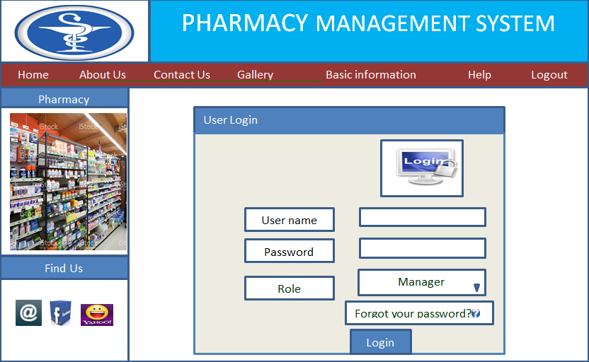

Figure1. 18 User Interface Design for Login

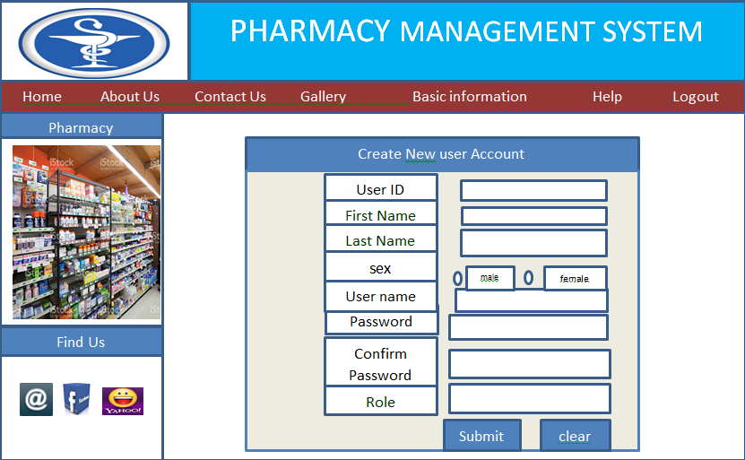

Figure1. 19 User Interface Design for Create New User Account

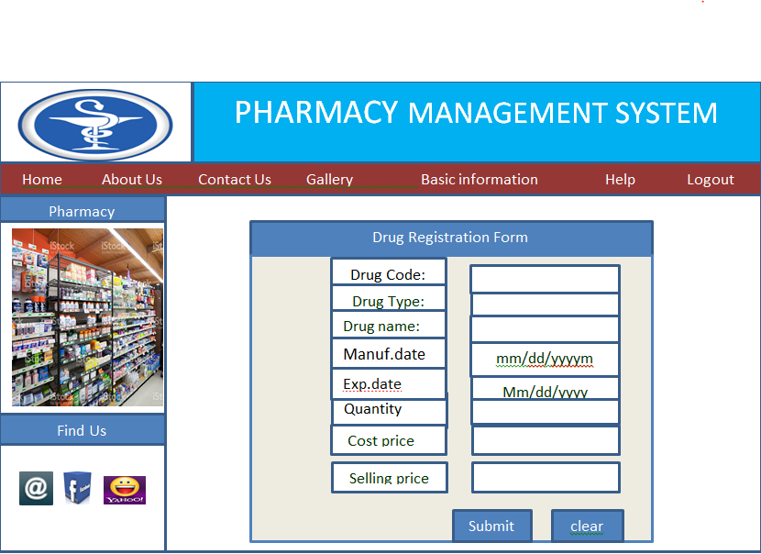

Figure1. 20 User Interface Design for Drug Registration Form

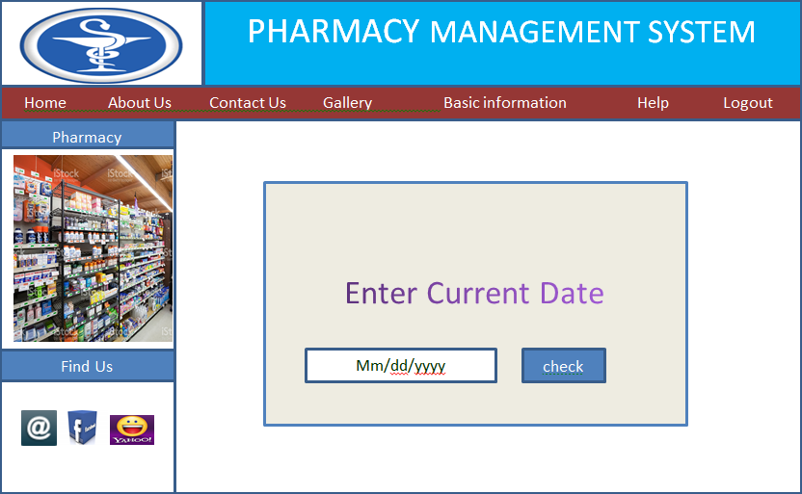

Figure1. 21 User Interface Design for Check Expired Drugs

## 3.3. Deployment Diagram

Deployment diagram shows all of the nodes on the network, the connections between them, and the processes that will run on each one. The client/server architecture of the system enables different clients to connect to the server remotely through Internet connection. Server side there is web server that is always connected with the internet for listening HTTP requests and accepts connection request and uses Apache HTTP server manipulates data from the database using PHP programs and answers user’s request. The web server also has program the prints card numbers. There is a database server that has MYSQL program which enable to communicate with the web server using SQL server

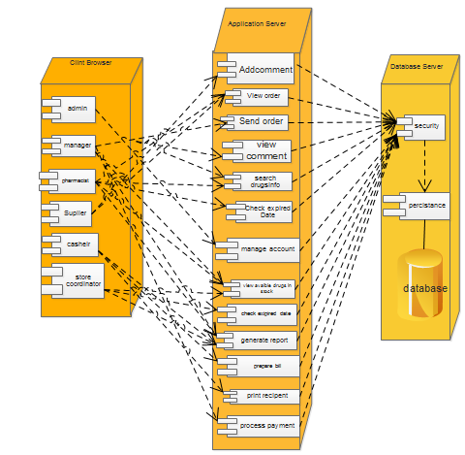

**Figure1. 22 Deployment Diagram**